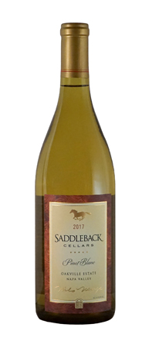 |   _{2017 Pinot Blanc}
 | _{Appellation:} | _{Oakville, Napa Valley}
 | _{Varietals:} | _{100% Pinot Blanc}
 | _{Harvested:} | _{September 9, 2017}
 | _{Cooperage:} | 5 months in 10% new French Oak barrels
 | _{Alcohol:} | _{14.1%}
 | _{Bottled:} | _{January 29, 2019}
 | _{Released:} | _{March 1, 2019}
 | _{Cases Produced:} | _{270 cases}

Our Pinot Blanc vineyard was planted in 1994, just south of our front door. This is our 20th vintage of Pinot Blanc exclusively from our estate, 100% Oakville. We handpicked 3 tons of Pinot Blanc on September 9th, 2017

FERMENTATION AND AGING:
After whole-cluster pressing and cold settling, the wine was racked into small stainless steel fermenters and inoculated with CY3079 yeast. Fermentation ensued and remained temperature controlled for approximately three weeks at 50 degrees until Brix reading dropped to seven degrees. At this point, the fermenting wine was transferred to 10% new, 90% neutral French Oak barrels for fermentation where it remained on the lees and stirred every two weeks while it aged for five months. The wine did not go through malo-lactic conversion

CHARACTERISTICS:
Find lilting aromas of baked apple pie and rhubarb in a swirl of the glass. On pouring, the wine is a pale gold; on the palate, flavors of rich stone fruit are bright and light, with a silky mouthfeel and long finish. Pinot Blanc's medium-light body generously lends itself to pairing with seafood, especially crab, shrimp, scallops and lobster, and composed salads. Lighter meats, including roast pork and chicken, are an ideal at the table. This wine's uniqueness lends itself to sharing, as well as sharing stories of your visit to Saddleback!
Pair with blonde pizza, sushi, Indian tikka masalas, roast, crispy skin chicken breasts.

